Volumetric calculation program

What is that?

The scanner MDL SLM Stockpile Scanner (MDA082) together with program volume.exe is intended for measurement of the stuff volume in a storehouse. The calculation of volume value occurs in a process of longitudinal motion of the rotating scanner over a surface of measured stuff. The scanner contains two sensor components:
- SLM – the rotating range and angle finder scanning cross-section cut of calculating area;
- IM – the range finder which determines a longitudinal position of scanner.

Installation

Run the received file volume.exe. In the field «purpose folder» choose the directory of installation. Click the button to extract. Open a folder in which you have installed the program and run a file volume.exe.
The installed program works in a demo mode. In this mode user does not see values in fields Free space and Lime volume – in all the rest program operation does not differ from full version.
For reception of full version of the program it is necessary to send to program developers a file volume.key which was generated by the program volume.exe – this file is in program root directory. After receiving the file volume.key, developers will send you another file with the same name volume.key which must replace generated earlier file volume.key in program root directory.
The program volume.exe will work in a full mode only on that computer on which the file volume.key has been generated.

Setup

All setup variables are located in configured file volume.ini.
The setup variables presented in a file are grouped on sections, namely:
- [slm] – section of setup variables of SLM of the scanner, namely:
- ip – a network address (value 192.168.0.10 is an immanent part of the given scanner and should not be varied by user);
- step – a step of changing an angle in degrees (the step can be set as one of two values: step=0.1 and step=0.01, and at that the last one - only in a mode freq=1; at other values of frequency of rotation the step will be equal to unique legal value 0.1, without dependence on the value which is set in a file);
- freq – frequency of rotation SLM of the scanner in Hz (frequency of rotation can change in a range from 1 to 10 including the step in 1 Hz; recommended value freq = 10 – thus step will be equal to 0.1);
- [lm] – section of setup variables for IM , namely:
- nComDist – the number of virtual COM port of getting an information from IM ;
- nComBatt – the number of virtual COM-port for getting an information from the scanner’s voltmeter;
- NameFileImitLM – the field is considered only when working in an imitation mode and contains a name of a relative path to a file of simulator of IM;
- [volume] - section of setup variables for the lime volume calculation model, namely:
- Lstart – the value of distance in meters by IM from which the calculations of lime volume begin (it’s chosen by user according to storehouse characteristics – see the description of field First of data area Lengths-limits; it is recommended to make value Lstart a little less than in initial position of the device so that calculations of lime volume could be begun after starting of longitudinal motion of the device);
- Lend - value of distance in meters by IM after which calculations of lime volume must be stopped (it’s chosen by user according to storehouse characteristics – see the description of field Last of data area Length-limits; it is recommended to make value Lend a little bigger than final position of the device so that calculations of lime volume come to an end before stopping of longitudinal motion of the device);
- Height - value of distance in meters from the centre of rotation SLM of the scanner down to a storehouse floor (it’s chosen by user according to storehouse characteristics – see the description of data area Height);
- Wleft - value of distance in meters up to the left wall of a storehouse if one looks on a longitudinal direction of the scanner motion (it’s chosen by user according to storehouse characteristics – see the description of field Left of data area Sidewalls);
- Wright - value of distance in meters up to the right wall of a storehouse if one looks on a longitudinal direction of the scanner motion (it’s chosen by operator according to storehouse characteristics – see the description of field Right of data area Sidewalls);
- model - number of mathematical model of the volume calculation (recommended value is 0 – in this case the simplified model of calculation with less dependence on error terms which can arise in the course of calculation) will be used; with any other value, in particular 1, the specified model of calculation with more dependence on error terms will be used;
-angmin - the minimum angle in coded units from which the calculation model starts to consider data from SLM of the scanner (by default value available is the least one of possible values – 9000, i.e. 90 degrees; this characteristic allows to cut off parasitic volumes, objects and not to consider its influence on calculations of lime volume; when assigning this angle user should take into account a direction of SLM rotation);
-angmax - the maximum angle in coded units after which the calculation model stops to consider data from SLM (by default value available is the biggest one of possible values – 27000, i.e. 270 degrees; this characteristic allows to cut off parasitic volumes, objects and not to consider its influence on calculation of lime volume; when assigning this angle user should take into account a direction of SLM rotation);
- rmin - the least distance in centimeters, less of which it is considered, that readings from SLM and IM are absent (see the description of field rbound of section [flags]);
- rmax - the biggest distance in centimeters, more of which it is considered, that readings from SLM and IM are absent (see the description of field rbound of sections [flags]).
- [history] – section of the setup variables connected with assigning the size of the historic arrays, namely:
- render – the field is considered only in an operating mode with rendering 3D (see the field render sections [flags] and contains quantity of the cross-section layers used in 3D rendering of scanning results;
- Im – quantity of the elements taking part in averaging of value from IM of the scanner (see field Im of section [flags] – it is recommended not to change a preset value 50).
- [times] – section of setup variables, which assigns time intervals of working with the scanner, namely:
- render – the field is considered only in an operating mode with 3D rendering (see field render of section [flags] and contains time of updating of graphic area in seconds; graphic area represents scanning results (values smaller than 1.0 can affect the process of receiving information from the scanner);
- result – time of updating of dynamic information in seconds in the field of representing of numerical results of calculation process of lime volume (values smaller than 1.0 can affect process of receiving information from the scanner);
- batt – the time interval in sec of inquiring voltage of the scanner voltmeter (because of the specificity of measuring averaged pressure values of the scanner values smaller than 5.0 do not affect the speed of receiving the voltage value);
- slm_answer – the maximum waiting response time in sec to a command from PC to SLM after which the decision about loss of linking with the device is made and repeated attempt of connection is carried out (values smaller than 3.0 can affect management process of SLM of the scanner);
- slm_control – the time interval in sec of connection verification with SLM (values bigger than 0.25 may affect by SLM control process).
- [flags] – section of the setup variables assigning operating modes of the calculating program, namely:
- imitmode – the non-zero value which assigns an imitation mode of IM of the scanner, thus information of IM is read out from a file defined by value of field NameFileImitLM of section [Im], and operation with the second virtual COM-port intended for receiving voltage value, is absent (this imitation mode of the program is intended for debugging and is not required for users);
- virt – non-zero value assigns taking into account virtual sidewalls in case of readings’ values from SLM, exceed the preset values of sidewalls (it is recommended to keep this operating mode of the program switched on);
- Im – non-zero value assigns taking into account fluctuations of values from the IM (it is recommended to keep this operating mode of the program switched on);
- negative – non-zero value which enables a mode of taking into account negative elementary volumes (this operating mode of the program allows to check the result received earlier at the expense of return longitudinal movement of the scanner, besides it allows to consider possible unforeseen fluctuations of longitudinal movement, therefore it is recommended to keep this operating mode switched on);
- rbound – non-zero value which enables a mode of additional control of values’ correctness from IM and SLM, and in case of detecting such fact as no readings presence, the program extrapolates the previous values of a distance on current ones from IM and SLM till the correct values will be received (it is recommended to leave the given operating mode of the program active);
- render - switches on a mode of rendering in a graphical form of scanning results, thus value 0 means absence of graphical rendering, value 1 switches on a mode of graphical visualization 2D, other values, in particular 2, switch on a mode of graphical visualization 3D.

Description

Run the file volume.exe. You will see on the screen a window of the volume calculation program (see fig. 1).

Setup of the operating elements:

- Scanning/Stop - the button of the start/stop of SLM rotation. It is always displays an action which the user can perform (the current state is opposite);
- Enable red dot point – the window of ON/OFF “red eye” pointer;
- Enable 3d image rotation – the window of ON/OFF of rotation scene in case of using graphic OpenGL 3D;
- Enable log to file - the window of logging an information from the scanner (it is possible to use only for several seconds because of great information volume – thus two files are created: slm.txt and slmoverview.txt);
- Cancel - an exit from the program.

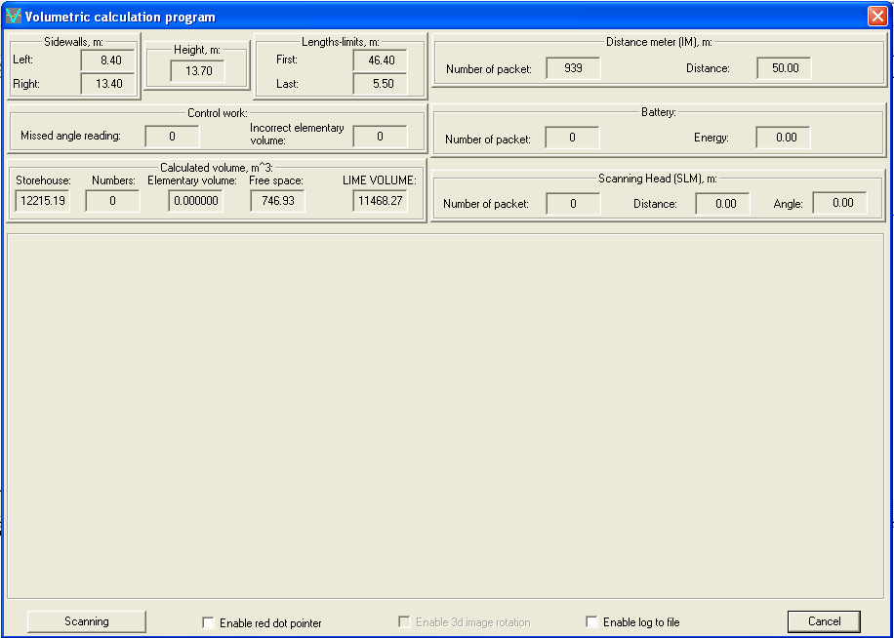

Fig. 1. The screen a window of calculating program of lime volume.

Setup of information data fields:

- The data area Sidewalls, m – contains constant (static) data in meters about sidewalls of a storehouse, namely:
- Left - value of distance up to the left wall of a storehouse if one looks on longitudinal motion of the scanner;
- Right - value of distance up to the right wall of a storehouse if one looks on longitudinal motion of the scanner.
- The data area Height, m – contains static data in meters about value of distance down to a floor of a storehouse from centre of SLM;
- The data area Length-limits, m – contains static data in meters about limiters of length of a storehouse, namely:
- First - the value of distance given by IM from which the calculation of lime volume begins;
- Last - the value of distance given by IM after which the calculation of lime volume stops.
- The data area Distance meter (IM), m – contains non constant (dynamic) data about the information arriving from the sensor, namely:
- Number of packet - current value of quantity of readings received from the sensor;
- Distance - current value of the longitudinal distance in meters which are given out by the sensor.
- The data area Battery contains dynamic data about information arriving from the voltmeter of the scanner, namely:
- Number of packet - current value of quantity of readings received from the voltmeter of the scanner;
- Energy - current value of the battery charge in volts.
- The data area Scanning Head (SLM), m – contains dynamic data about the information arriving from the sensor, namely:
- Number of packet – the current value of quantity of network packages (there are 182 readings in one network package) which are received from SLM;
- Distance - the current values of distance in meters which are received from SLM;
- Angle - current values of angle from SLM in degrees.
- The data area Control work – contains dynamic data of control information about process of scanning of the lime surface, namely:
- Missed angle reading – the current value of the counter of missed angles from SLM;
- Incorrect elementary volume – the current value of the counter of incorrect elementary volumes (when one or several sides (edges) of elementary volume have zero length for some reasons).
- The area of data Calculated volume, m^ 3 – contains data about results of calculation of lime volume, namely:
- Storehouse – contains value of storehouse volume in cubic meters according to data that contains in the configured file of program setups;
- Numbers – contains current value of the counter of elementary volumes;
- Elementary volume – contains current value of elementary volume in cubic meters;
- Free space – contains current value of the measured volume of free space over a lime in cubic meters;
- LIME VOLUME – contains required current value of the measured lime volume in cubic meters which issues as result of subtraction the current volume value of free space over a lime from the volume value of storehouse.

Preparation

Before the beginning of work with the program it is necessary to make sure that in properties of protocol TCP/IP of network connection the automatic mode of receiving an ip-address is chosen because the scanner contains built-in DHCP-server which should give a free ip-address to the client. If nobody changed settings, OC Windows XP chooses the given operating mode by default.
Procedure on hardware and software package:
- Connect the scanner with the network.
- Make sure that laser mark (the red eye) of IM of the scanner is visible on an opposite distant wall of a storehouse.
- Switch on the computer and wait, when OC Windows XP will be loaded and DHCP-server of the scanner will give out an ip-address to the network controller of the computer.
- Define the size of a calculation zone (the size of the storehouse) if they were not measured yet or for any reasons have changed and in case of necessity to change parameters of configured file of program settings (see section [volume] – fields Lstart, Lend, Height, Wleft, Wright). It is recommended to choose the value Lstart a bit less than one the device starts of so that calculation of lime volume would begin after the beginning of longitudinal movement of the device. And it is also recommended to choose the value Lend a bit more than one of final position of the device so that calculations of lime volume could be stopped before the end of longitudinal movement of the device.

Working process and control of results

- To start process of measurements of lime volume - run the calculation program volume.exe.
Make sure that values displayed in fields of data areas Sidewalls, Height and Lengths-limits (see fig. 1), correspond to storehouse characteristics which set in configurable file, and required value of lime volume LIME VOLUME correlates with analytically calculated volume of storehouse Storehouse (see the area of given Calculated volume). But there is an exception for the following case when the values of angmin and angmax differ from 9000 and 27000 accordingly being lessened because the SLM measures a distance to the lime surface, and the calculating program calculates (measures), as a matter of fact, the volume of free (empty) space over it. In this case the starting value of the LIME VOLUME will also differ from the value of the storehouse volume and will less on the value which was cut off by those angular terminators prolonged over all length of the storehouse.
- Make sure that value of longitudinal distance to an opposite storehouse wall goes to the program and corresponds to the real current range (field Distance of data area Distance meter (IM)) by changes of field value Number of packet of data areas Distance meter (IM).
In case of using the battery for supply of the scanner, information of data area Battery (see fig. 1) can be useful.
- To start the SLM rotation and firing click the button Scanning (see fig. 1), thus the button will change the name for Stop, and the SLM head will start to rotate with the speed preset in the field freq of configurable file.
For the control of working process of SLM it is possible to switch on beforehand the red eye laser of the SLM by a choice of field Enable red dot pointer.
Field Enable 3d image rotation has action only in a mode of graphic rendering 3D.
It is not recommended to switch on field Enable log to file as amount of information written down on a hard disk is so great, that there may be not enough free space.
- Make sure that distance values from SLM of the scanner arrive in the program and correspond to real size (current instant value of distance is displayed in the data field Scanning Head (SLM) in the field Distance and corresponds to angle Angle) by changing of value of field Number of packet of data area Scanning Head (SLM) (see fig. 1).
If longitudinal position of the scanner is out of set range of calculation (terminators First and Last), fields values Numbers, Elementary volume and Free space of data area Calculated volume will remain initial, as well as field Incorrect elementary volume of data area Control work, that means the program section of calculation of lime volume doesn’t work.
By field value Missed angle reading of data area Control work one can see the quantity of missed angular steps of SLM what can be connected, first of all, with a great computation load upon the computer (for example, in a mode of graphic rendering) or errors in scanner’s work. If result of calculation of lime volume is wrong by the constant incremental change of this value, it will be necessary to restart the program.
- In the process of device movement first of all it is necessary to control field Distance of data area Distance meter (IM) in order this value has forward smooth change, without sharp splashes and jumps – in an opposite case the process of measuring the lime volume must be repeated once again. This situation can take place because of insufficient smoothness of the course, poor reflecting properties of an opposite wall of a storehouse that result in a loss of readings from IM.
When entering a calculation zone (value of field Distance of data area Distance meter (IM) becomes less than in the field First) values of dynamic fields of data area Calculated volume change, up to an exit from a calculation zone. The value of field Numbers shows quantity of elementary volumes (a current instant value of elementary volume is displayed in the field Elementary volume), summed up for receiving of volume of free space over lime (field Free space) which is subtracted from constant volume value of a storehouse (field Storehouse) for receiving of required value of lime volume (field LIME VOLUME).
- When leaving a calculation zone, that can be observed as a stop of changing information in dynamic fields of data area Calculated volume, it is necessary to give command to stop.
If there are no jumps and splashes of value Distance of data area Distance meter (IM) in the process of measuring, received in the field Lime Volume one can consider the final result as correct one.
- For checking out the calculated result it is possible to give the command on moving in the opposite direction up to an exit from a calculation zone without switching off the scanner.
If there are no jumps and splashes in size Distance of data area Distance meter (IM) in the process of measuring, the result received in the field LIME VOLUME must agree with the starting value which is given out by the program before process of scanning. On the difference between starting and received by scanning values it is possible to judge about the result’s error.
- To stop firing and rotation of SLM of scanner, click the button Stop.

